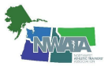
NWATA Members Meeting
Thursday June 30th, 2022
Philadelphia, PA

Attendance 40

1)Welcome Director Fitzpatrick
Called to order at 5:53 pm EDT

First time attendees: 6, welcomed
Recent BOC passed: 3, Congratulations!!

Motion to approve minutes from NWATA Members Meeting in Portland, OR 4-1-22
Motion: Greg Mitchell
Second: Jodee Roberts
Ayes: all, Nays: none, Abstentions: none

2) Secretary’s Report
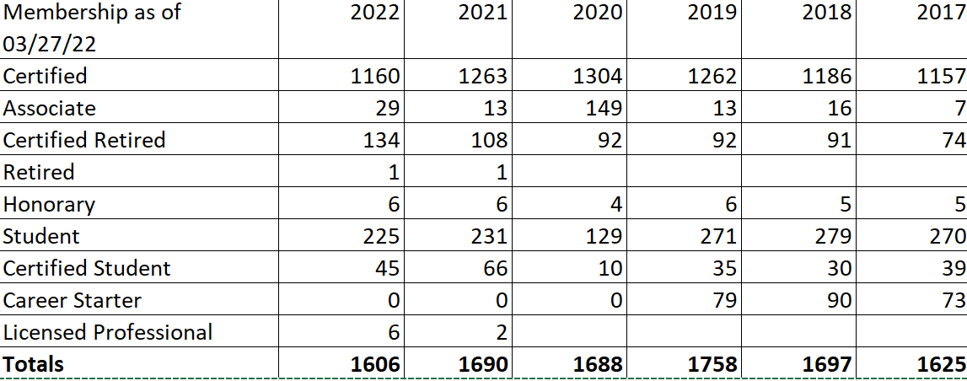

NATA has started auto renewal program for dues and you can pay monthly by doing this, plus you lock in current dues price if you renew before the fall.

3) Treasurer’s Report
Umpqua
Checking: $103, 352.81
Savings and Investment: $55,247,36

Raymond James
Investment: $35,833.24

Garth Babcock will be running for a second term and we will vote in the Fall with a vote of affirmation email.

4) NATA Foundation Update
Scholarships—3 students from D10
EDAC DAVID PERRIN Jaume Amengual, BSU
D10 MARK SMAHA Hannah Boutwell, UOFI
JIM WHITESEL Madeline Eliassen, Pacific University

Best Literature Review: Sola Yeager and Tedi Jo Pederson from Univ of Montana

5) NATA Committee Updates
-JCM and Committee Day were virtual this past year
A )Jodee Roberts newly appointed to LGBTQIA+ committee
i)recruiting reps from every state
b) Jeff Kawaguchi, EDAC Chair
i)service project on June 28th
ii)Met in person yesterday here in Philadelphia
iii)EDAC sponsored lecture at NATA was given by Jeff
iv)EDAC needs state reps
v)Voices of Color Video series—working on more videos to be posted
c) Dustyn Walton---recently voted as chair for SLC
i) Kayla Biddle, new sitting D10 rep, voted to replace Dustyn as chair when he rolls off
d) Bill Drake, NATA Foundation
i) reminder that the position statements are done by the Foundation and are updated every 2-5 years
ii) Circle of Champions---300 ATs nationwide, D10 has a great representation but we would like to see more. You can join at ANY dollar amount--$1/mo, $5/mo, etc
iii) Cornhole will return to the next D10 meeting in Spokane—entry fee negotiations for more student involvement
iv) Howl at the Moon event donations are still open til 9pm tonight EDT, and Director Fitzpatrick is in the contest for karaoke
e) Chris Ludwig, Convention planning committee
i) Themes: data driven outcomes, optimizations for RTW/RTL, DEIA
ii) June 21-24, 2023 in Indianapolis
f) Lisa Kenney, ATs Care
i) has had a more quiet season these past few months as far as incidents needed responded too,
g) Lynne Young, SSATC and SAAC
i)ATLAS will reopen on August 1st, update your school info
ii) Safe Sport School Awards has gone all online for applications
iii)SSATC sponsored lecture is tomorrow AM: Vitamin D and HS students
iv)AYOR revamped and website is easier to use
v) State Leadership Forum, July 19th 3-7pm EDT
h) Jessi Cole, EPC
i) still in process of education of membership on the split from YPC; did Phillies game and Pinky Newell reception
i) Ciara Ashworth, COPE
i) new code of ethics posted on NATA website—addresses a larger scope, includes CIRCA principles from PRAT
j) Gen Ludwig, EAC
i)voting on professional development grants soon, Gen encourages more to apply as it is a forgotten grant and there are few applicants
7) Board updates
a) Go4Ellis
i)changed name to Go4; also now hires RN since Covid for screeners
ii) 16,012 HCP
iii)3881 Companies
iv)3 step sports youth sports camp
v)Average pay is $48/hr—increase of $14/hr since 2021
vi) Since inception--$8.4 million earned by ATs
b) Oral History Project—History and Archives Committee
i) Project from the NATA to capture history from members
ii)Tell your story!
iii) 900 stories captured so far
iv) open for 6 months
c) 3rd party reimbursement Initiative
i)alignment of state, district and national efforts
ii)development and promotion reimbursement and regulatory best practices
iii) deliver payor, employer, and governmental affairs advocacy
iv) provide formal advisory services to states/districts
v) GA boot camp precursor to doing TPRI boot camp
d) AT and Public Health Task Force
i)approved toolkit that will assist CAATE to help guide new ATs to Public Health careers
ii)webinars: Suicide and the Secondary/Collegiate Athlete
8) Old Business
Thank you to outgoing past president Cari Wood
9) State updates
i) Ciara Ashworth/Washington: state meeting registration will be open in the next few days. Will be in Yakima on July 23rd
ii) Lynne Young/Alaska: business meeting only this July,
10) Thank you from Director Fitzpatrick
--to ALL of NWATA
--to the 139 present in Philadelphia
---the committee chairs
--State presidents
--to past and present BOD: Ben, Craig, Cari, Chandra and Garth
--to his chosen family and “ride or die crew”: Greg Mitchell, Nikki Clark-Vega, Pam Arriola
11) NEW business
OFFICIAL transfer of directorship at 6:53pm EDT, to Kasee Hildenbrand
Huge THANK YOU to Tony Fitzpatrick and presentation of plaque
We are needing to change signers on all accounts at Umpqua bank : XXXXXXXX48 and XXXXXXXX52. The following person will be removed: Anthony (Tony) Fitzpatrick. Kasee Hildenbrand has been elected president/director, and she needs to be added to all accounts as signer. She will also need to be ordered a new debit card.

12) Motion to adjourn
Gen Ludwig, motion
Ciara Ashworth, second
Vote: all in favor
ADJOURNED AT 6:54PM EDT

