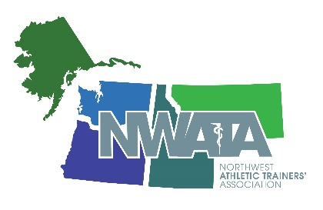

NWATA - District 10
Virtual Zoom Member Meeting Minutes
Monday, June 29, 2020 - 7pm Mountain

Called to order: 7:00 PM Mountain
In attendance: 68 Members

Approval of June 25, 2019 Meeting Minutes from Las Vegas, Nevada
37 approved (all voted) – Minutes are approved.

Secretary’s Report

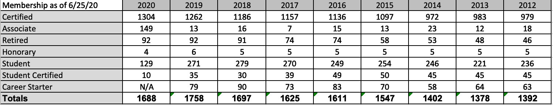

Treasurer’s Report

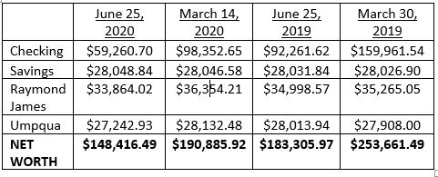

- In 2019-20 we were able to draw $1500 from the Raymond James investment account to go toward our $8,000 in scholarships that we award and $1000 from the Umpqua investment account to go toward the general budget.
- 2020 NWATA Annual Meeting and Clinical Symposium to be held in Boise in March was cancelled. Some costs for the 2020 meeting can be rolled over and will help reduce operating costs of the 2021 meeting in Bellevue. This budget also accounts for the $17,500 deposit that has been paid over the past three years per our contract with The Boise Centre and will be credited toward our meeting in Boise in 2024. As a result of canceling the 2020 annual meeting we ended up with a meeting budget deficit of $21,462.30 compared to our expected surplus. Our operating budget separate from the annual meeting budget was a surplus of $7602 for fiscal year 2019-20.
- Due to the pandemic the market has also been affected which includes our investment accounts. We have a stable investment plan and will continue to work with our respective account advisers to ensure our investments remain in alignment with the goals of the NWATA investment planning.
NWATA Meetings Update – Dani Moffit – 2021 NWATA meeting in Bellevue, March 12-13, Workshops on the 11th and 14th. ICEU Virtual Platform for providing CEUs online. This will bring money directly back to the district/states. Call for proposals will come out at the beginning of August.

NWATA Student Senate Update – Maddy Hiatt (Student Senate President). Working on a theme for the student symposium.

NATA Foundation Update - Jimmy Whitesel Scholarship fully funded and endowed. My Cleats My Cause – Seahawks/Dave Stricklin and Seahawk TE Will Dissley. NBATA Foundation of $1000 lead by the Portland trail Blazers head AT Geoff Clark. Donate a Photo through J&J for the NWATA foundation. Corn Hole tournament will be held in Bellevue at the 2021 NWATA District Meeting.

NATAPAC Update - 2019 donations - $4,427.14. Welcome to Tom Bair, our new NATAPAC NWATA Chair.

NWATA District 10 News and Updates
- NWATA Committee Updates
  - International Committee - The IC has created new resources related to COVID-19 combating detraining & educating patients/clients about xenophobia
  - Research Committee - Congratulations to our 2019-2020 research grant winner Shane Murphy - “Utilizing Wearable Sensors to Determine Joint Kinematics during Dynamic Tasks of a Return to Sport Protocol”.
  - Student Leadership Committee
    - VNATA Student Symposium – Will be virtual symposium, July 13-16 will be live and then recorded for 60 days. Free for all students
    - NATA Chats – Will happen on June 30th on Facebook Live, students will be asking our candidates questions.
    - Upcoming PEC Panel – 5 Athletic Trainers to discuss how COVID-19 effects clinical education.

- State President Reports
  - Alaska - vAATA State Meeting will be july 24th 8-12pm AKST. Alaska ATs assisted with community screening since March. ATs working with school districts to assist with mitigation plans and navigating through RTP.
  - Idaho - IATA Virtual State Summer Symposium will be July 25th 8am – 12pm (4 CEs) Conducted our 2nd Hit the Hill Day. Updated IATA by-laws. Idaho won the NATA GAC Dan Campbell award.
  - Montana - The MTATA split the secretary/treasurer position in the fall of 2019. Dustin Burton, MBA, LAT, ATC, CSCS was elected as the new MTATA Secretary. Hosted the virtual MTATA Meeting June 10 – 12 (4 CEs )
  - Oregon - Legislative Action – SB 742: Licensure & updated practice act 0 Started January 2, 2020. SB 4140: Return to Learn concussion bill (ODE) - The bill to require the ODE to develop an academic accommodations form for returning to school following a brain injury was signed by the Governor.
  - Washington - Success in Washington during COVID-19, in that we were successfully able to work with the Department of Health and L&I to have athletic trainers added to the list of approved providers with L&I to be able to bill and be reimbursed for telerehab.. State clinical symposium has moved to a virtual symposium on July 18 starting at 8:30am PDT. 5 CEU's with 3 EBP CEUs pending EBP approval .

Member Recognition
- Outgoing Chairs
  - NATAPAC D10 Director - Dana Gunter
  - NATA ECE D10 Representative - Suzette Nynas
  - NATA EDAC Chair - Grant Wilson
  - NWATA GAC - Lynne Young
  - NWATA Meetings Coordinator - Aaron Kilfoyle
  - NATA PPEC D10 Representative - James May
  - COPA – Luke Bahnmaier
  - NATA PDC D10 Representative - Jonathon Huwe
  - NWATA SSAT Chair - Shelly Jones
- Welcome our Incoming Chairs
  - NATAPAC D10 Director - Tom Bair
  - NWATA GAC - Sam Johnson
  - NATA PDC D10 Representative - Emily Norcross
  - NWATA SSAT Chair - Lynne Young
  - Meetings Coordinator – To be filled
  - PPEC – To be filled
- NWATA Scholarships
  - NWATA Post-Professional Scholarship - Colin Mulligan - OSU
  - Richard Irvin Professional Scholarship - Macaylea Mitchell - OSU
  - Naseby Rhinehart Professional - Ryan Clark - UI
  - Bill Robertson Professional Scholarship - Shay Hannigan-Luther - OSU
  - Bob Peterson Post-Professional - Madison Hiatt - BSU
  - St. Luke’s Emerging Practice - Molly Murphy - OSU
  - NWATA Family - Mira Wibel – Spokane Classical Christian School
- NWATA Awards
  - NWATA Research Grant - Shane Murphy, PhD, LAT, ATC
  - NWATA New Horizon Award - Kaleb Birney
  - NWATA Service Award - Sam Johnson, PhD, ATC
  - NWATA ElevATe - Larry Howe, Lisa Kenney, Valerie Moody
  - NWATA Directors Award - Greg Hill, Jennifer Krug
- NATA Awards
  - NATA SSATC District 10 Athletic Trainer of the Year - Kari Cunningham, ATC, Sunset High School, Oregon
  - Athletic Training Service - Sam Johnson, PhD, ATC
  - Most Distinguished Athletic Trainer - Cari Wood, ATC

Director’s Report
- NATA Covid-19 Resources - All NATA Committee Created Resources for COVID-19 can be found on the NATA Home Page
- NATA Spine Injury Sport Group - NATA Spine Injury in Sport Group materials were recently released
- NATA AYOR - Becoming a powerful resource especially in light of what is going on regarding COVID-19 and HS/College programs losing ATs
- Strategic Partners – Gave updates on all partners of strategic alliance
- Regulatory Update
  - NATA submitted comments on - Pain Management Best Practices Inter-Agency Taskforce, CMS Opposing move of OTS orthotic products into competitive bidding, CMS in response to Medicare Advantage Call Letter and non-opioid pain management practices, DOD’s proposed rule for TRICARE and the prescribing of PT, OT, ST and other allied health professionals to support the inclusion of ATs
  - Medicare Enrollment/Billing Privileges and Medicaid Managed Care - Promote efforts to obtain data to demonstrate value of AT provided medical care. Committed to extending Medicare enrollment and billing privileges to certified ATs . Use data obtained from its TPRI and ACO demonstration projects to promote the coverage of ATs by Medicaid Managed Care Plans
  - Department of Labor
    - Occupational Licensure - Actively opposed deregulation of ATs and other healthcare providers. Continue building relationships with NCSL, ALEC, NGA, DOL and other to ensure appropriate licensure and portability
    - Occupational Safety - Continue monitoring/evaluating new OSHA Policies, Ensuring they don’t impede on the AT’s ability to provide services for workers employed in industrial settings

- NATA Board of Director Actions
  - Approved funding for the SAAC Leadership Fellow Program
  - Approved the formation of the NATA Athletic Training and Public Health Integration Task Force - Mark Hoffman is the chair
  - Approved the DST Committee Allied Health Professional Benchmark Project - A resource that compares other allied healthcare professions benchmarking their member dues, benefits and annual meeting provided to their members
  - Endorsed the multi-association document “Return to Sports and Exercise during the COVID-19 Pandemic: Guidance for High School and Collegiate Athletic Programs” - ACSM, AMSSM, AOSSM, CSCCa, GSSI, KSI, NATA, NCSSIR, NFHS, NSCA, US Soccer
  - Occupational Safety Continue monitoring/evaluating new OSHA Policies Ensuring they don’t impede on the AT’s ability to provide services for workers employed in industrial settings
  - Approved the formation of the NATA Infections Disease Control Taskforce - Tasked with developing Infections and Disease control recommendations for the Collegiate and Secondary School Setting.
  - District 11 approved – Illinois, Minnesota, Wisconsin. Will begin Jan 1, 2022

- Future Meetings – 2021 – Orlando, 2022 – Philadelphia, 2023 - Indianapolis
- NATA Presidential Election – Voting to take place July 1-July 31

NWATA Old Business
- Ben Henry will roll off Secretary and Chandra Lovejoy will assume Secretary roll.

NWATA New Business
- Accepting Nominations for NWATA Treasurer - Send Letter of Interest and Current Vitae to Cari Wood at cari.wood@redmondschools.org Due July 31, 2020. Election will run September 1 – 30, 2020

Adjourn: Ben made a motion to adjourn the meeting, Second – Craig. Meeting adjourned at 8:35pm Mountain

