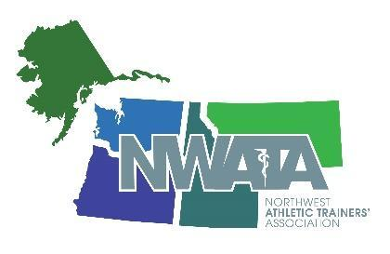

NWATA - District 10
Virtual Member Meeting Agenda
Monday June 28, 2021 6:30 pm – 9:00 pm Mountain
Zoom Meeting
Meeting ID 862 0163 3961
Security Passcode 468205

- Meeting Called to Order 6:30pm MOUNTAIN
  - 50 participants online

- Approval of the March 13, 2021 Meeting Minutes as Posted on the NWATA.org Website
  - Motion: Charles Liggett
  - Second: Valerie Moody
  - Vote: all Ayes, Vote passed

- NWATA Secretary’s Membership Report - Chandra Lovejoy
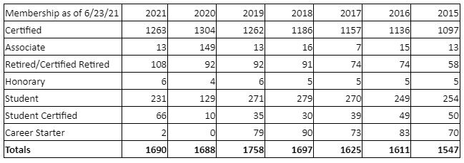

- NWATA Treasurer’s Report - Craig Bennett 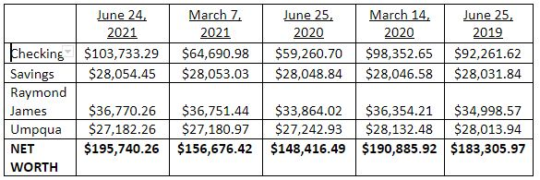
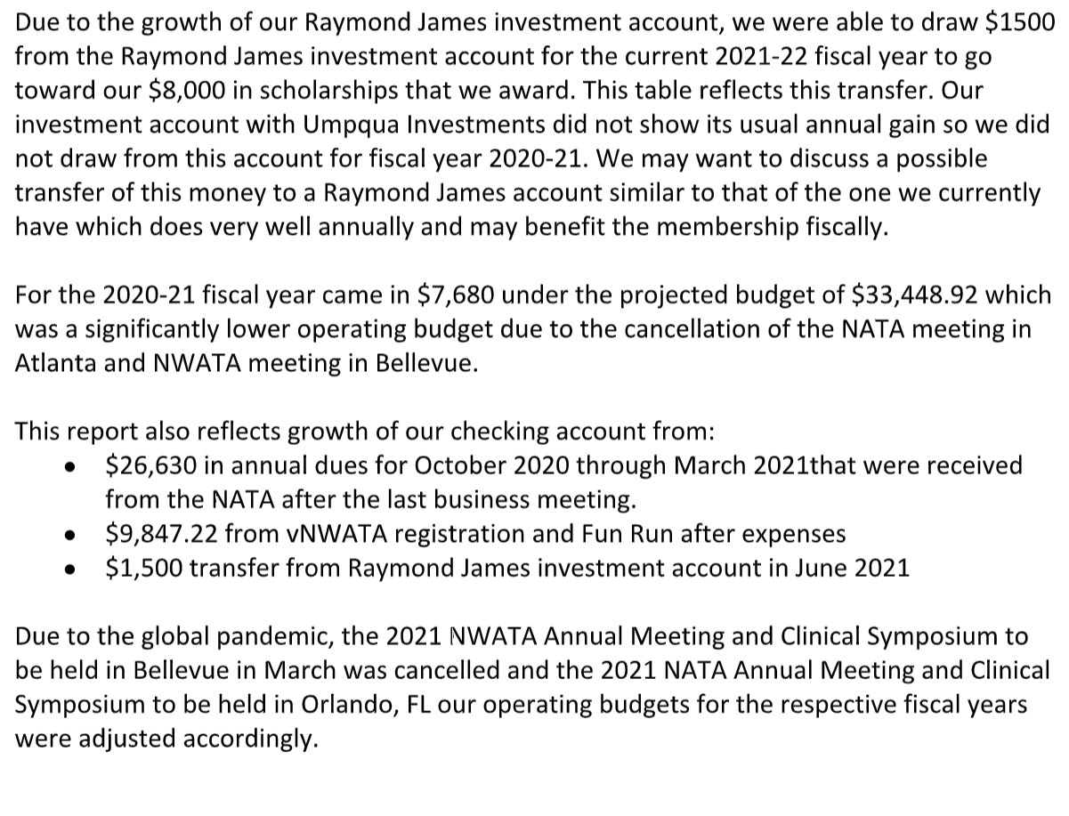

- NWATA Student Senate Update - Dylan Rinaldini, NWATA Student Senate President
  - New group of student senators; planning meet and greets with students (virtual), asking Program Directors to help spread the word.

- NWATA State Association Reports
  - Alaska - Lynne Young, President
    - Developed mitigation plans for state with COVID, sent to ATs; worked on GA projects; having a business meeting only this summer; working with SAAC with self-sufficiency ie costs for lobbyist, rebuilding BOD due to board members maternity leave and entering PA school
  - Idaho - Luke Bahnmaier, Vice President
    - Summer symposium Virtual IATA-July 20th and 27th, evenings, ~3.5 CEUs. One candidate for IATA President. IATA will award Tony Fitzpatrick the IATA Hall of Fame award
  - Montana - Paul Capp, President
    - Successfully defeated a bill aimed to dissolve 16 professional licensing boards in Montana and move them all under the Montana Board of Medical Examiners. Athletic trainers would not have a guaranteed seat on the proposed composite board, putting the profession at risk of under or mis-representation and future policy decisions being made with their input.
      - Will be working with lobbyist to build relationships with other health care professional associations in preparation of 2023 Montana legislative session
    - Virtual Montana State Meeting held on June 19, 2021
    - MTATA will be moving Russ Richardson onto the Executive Council as Treasurer
      - We thank Janelle Handlos for her 15+ years of service to the MTATA as Secretary/Treasurer and helping to build our association to where it is today!
    - 2021 MTATA Awards
      - MTATA State Recognition Award
        - Brian Straub, LAT, ATC, NASM-CES (Formerly of Kalispell, MT)
        - Erin Harbaugh (Former MTATA Lobbyist)
        - Janelle Handlos, PhD, LAT, ATC (Dillon, MT)
      - MTATA Distinguished Service Award
        - Matea DePoe, MS, LAT, ATC (Billings, MT)
      - MTATA Hall of Fame
        - Valerie Moody, PhD, LAT, ATC, CSCS (Missoula, MT)
  - Oregon - Heather Halseth, President
    - OATS CEU sessions over the summer- on-demand, 4 sessions: available July 26th. Several open positions available in Oregon
  - Washington - Ciara Ashworth, President
    - WSATA summer CEU event July 24th, 3 sessions;

- NATA Foundation - Bill Drake, D10 Foundation Director
  - 16 research award scholarships,
  - Looking for ideas from members for connecting better with students
  - Exploring ways to develop DEI within the Foundation to align with Strategic Alliance goals
  - Circle of Champions-regular donors, getting members involved at any dollar amount to help support D10 efforts towards Foundation scholarships.

- NATAPAC - Tom Bair, D10 NATAPAC Director
  - Board is in a bit of leadership transition.
  - NATAPAC is also accepting monthly donors: you must be a NATA member to donate due to legal rules.
  - Special thanks to Dana Gunter and NWATA for supporting Tom in his bereavement leave.

- NWATA - District 10 Committee News & Updates
  - Council on Practice Advancement (COPA) - Occupational - Jill Harvill
    - COPA noticing members leaving NATA, potentially because there is not enough value for occupational ATs (CEU, etc); working diligently on showing value to those members as that job setting will grow rapidly
      - Developing alignment for OSHA certification and BOC credit through the universities
    - Developing a series of Facebook live and fireside chats focused on the occupational and industrial AT
  - Career Advancement Committee (CAC) - Matthew Smitley report submitted
    - Inaugural meeting
      - Looking for state members
      - Working on mission and vision
      - Want to create a CAC award for NATA
      - We looked at the preliminary results of the NATA YPC Survey and discussed how we may be able to utilize that info to guide the CAC at the national and district level
    - CONGRATULATIONS to Matt and his new wife, who were married yesterday 6/27/21- from your NWATA family
  - Early Professional Committee-Clayton Malinich report submitted
    - The Early Professional Committee had our first meeting on 6/17/21. Most of what was discussed was regarding the basic rules of how to operate a NATA committee and getting to know each other. Official business revolved around what committees we will be working closely with as well as establishing a mission and vision of our new committee.
    - This is a very exciting time and I can't wait to see what the split of the YPs has instore
  - International Committee - Cynthia Wright
    - Renewing CATA partnership; developing resources by translating NATA documents into other languages—looking for native speakers (ATs) to proofread professional translations for medical correctness.
    - Continuing work on resources to support International ATs and to those who WANT to go International.
    - Available at NATA.org > Professional Interests > International > Resources
  - Professional Responsibility in Athletic Training (PRAT) - Midge Peterson
    - Collaborating with COPE to include NATA shared professional values into the Code of Ethics
    - Developing presentations for KI, CAATE, ATEC, NATA2022
    - Assembling pertinent membership resources related to LERPS practice issues
  - Ethnic and Diversity Committee (EDAC) - Jeff Kawaguchi
    - Partnering with ATs Care for Call in nights
    - Created Twitter account: @EthnicNwata
    - Working on Diversity Enhancement grant
    - Still working on EDAC state reps/committees
  - Governmental Affairs Committee (GAC) - Sam Johnson
    - Non-financial resources available-webinars staring in the Fall
    - Committee meets again in July
  - Secondary Schools Athletic Trainers’ Committee (SSATC) - Lynne Young
    - Discussed suggestions to make PASS not so intimidating
    - SSATC has a GATHER Community
      - Safe Place to have discussions and ask questions
    - Safe Sports School Award (SSSA)
      - Have you applied?
      - NWATA has 2 grants per state
    - Working with HOSA for co-branding opportunities
    - COVID Resources online for the SS AT
  - NWATA Meetings - Gen Ludwig
    - Janelle Handlos present with Gen for her update
    - Portland, 2022: 50TH anniversary of the NWATA
      - March 31-April 2, 2022
      - Cari Wood is leading Anniversary celebrations committee
  - LGBTQIA+ Advisory Committee-Ben Henry report submitted
    - Discussing a revision of NATA Membership Self Identification Questions.
    - Safe Space Ally Training – Webinar has been a success so far with over 100 participants in the first month of release. The committee has been receiving requests to host in-person/virtual training beyond the webinar. Will be creating a “2nd level” SSAT course.
    - 2022 Convention – two courses will be in works
      - Overcoming barriers to providing healthcare to LGBTQ+ population
      - Healthcare disparities with the bisexual population
    - Working on continuing webinar series in collaboration between NATA LGBTQ+, APTA/AASMPT DEI, and NSCA DEI
      - Webinar #2: Health Care Disparities, July7th. https://community.aaspt.org/events/56871
      - Webinar #3: Creating a Welcoming Environment for LGBTQ+ Athletes (More to come)
    - Pride Month social media has been a huge success! Will continue to focus on social media activity throughout the year to provide information on awards, grants, important holidays, and overall LGBTQIA+ AC activity.
    - Thank you to Dani Moffit who rolls off as NWATA LGBTQIA+ AC Representative. New representative will be Ben Henry
  - PEC-Dana Bates report submitted
    - Preceptor Chat series: The goal of the Professional Education Committee Preceptor Chats initiative is to provide and promote a preceptor led/preceptor attended professional development opportunity.
    - Coming Soon Clinical Education Coordinator Chat series: The goal of the Professional Education Committee Clinical Education Coordinators Chats initiative is to provide and promote a Clinical Education Coordinators led/Clinical Education Coordinator attended professional development opportunity.
    - Dates and topics can be found with the link below:
      - https://www.nata.org/professional-interests/job-settings/higher-education/resources

- NWATA Directors Report
  - Strategic Alliance Updates
    - BOC
      - Orthopedic Specialty Exam Important Dates
        - Registration - July & August
        - Handbook available July 1
        - Exam - September
      - AT Director Opening
        - Application due July 5
      - BOC360 opening early July
        - Information coming soon
      - Go to bocatc.org for all information
    - CAATE
      - Residency & Fellowship Standards are posted on the CAATE Website
      - Call for Commissioners
        - Application due July 1, 2021
      - Go to caate.net for all information
  - AT EducATionalist
    - Cabinet positions open-open to ANY AT interested in education at any point in the professional education spectrum.
      - Deadline 7-20-21, contact Director Fitzpatrick for application form
  - Board Room Updates
    - Approved the NATA Public Health Task Force
    - Approved the change of a D1 at-large ICSM member to a dedicated HBCU representative position
    - Approved the joint mental health statement from the AAP and AOSSM
    - Approved the NATA Diversity, Equity, Inclusion and Access Task Force
    - Approved the NATA Infectious Disease Workgroup White Paper
    - Mental wellness for youth athletes during the Covid-19 Pandemic
    - Approved an NATA Cannabinoid Task Force
      - Address demand for information related to cannabis and cannabinoid products
      - Present Best Practices and EBP materials for members
    - President Dieringer created a Compensation Task Force to explore all the different facets that affect AT compensation
    - D10 Approved the D4 Split to D4 & D11
    - D10 was the VNATA2021 Quiz Bowl Champions
      - Congratulations to Owen Mainord, Kailey Warren and Jon Cerna

- NATA Resources
  - Employment Fair Practice Workgroup
    - Glossary for ATs
    - AT Tool: What to look for in an outreach contract
    - Athletic Training Contracting: What you need to know about Referral Legislation
    - Glossary for Employers
    - Employer Tool: What to include in an Outreach Contract
  - Value Models
    - SS Value Model-updated for “post-Covid” world
    - College and University
    - Physicians Practice
    - Athletic Training in Public Safety
  - Spine Injury in Sports
    - Consensus Recommendations on the Prehospital Care of the Injured Athlete With a Suspected Catastrophic Cervical Spine Injury
    - Best Practices and Current Care Concepts in Prehospital Care of the Spine-Injured Athlete in American Tackle Football
    - Spine Injuries in Sports-Managing On-Field Cervical Spine Injuries Produced by the Sports Institute at UW Medicine
  - ICSM
    - Care of the Patient in Prevention of Transmission of Infection
    - COVID-19 Related Athletic Training Infection Control: Prevention of Infectious Disease
    - Infection Control in Athletic Training Facilities Post-COVID 19 Facility Standards
    - NATA Infection Control Infographic

- Future NATA Meetings
  - Philadelphia - June 17-20, 2022
  - Indianapolis - June 21-24, 2023

- NWATA Old Business
  - Thank you to Craig! The NWATA is grateful for your last 4 years of service as Treasurer and your continued advisory role on the finance committee with Garth
- New Business
  - Welcome to our New Treasurer, Garth Babcock, starts position this week.
    - Financial committee to be formed to include past treasurer for continuity
  - NWATA Board approved an NWATA EDAC Proposal to add a Graduate Student Member
  - NWATA Board approved a proposal to rebrand NWATA-D10 Cornhole
    - Honor Rachel Oats’ Legacy and her passion for NWATA and our cornhole event
  - Call for Elections
    - Secretary Vote of Affirmation -Chandra has indicated her intent to run for her second term
    - District Director / President Election
      - Official call, Director Fitzpatrick will roll off at Philadelphia meeting.
    - Call for Nominations
      - Send LOI and Vitae to Cari
      - cari.wood@redmondschools.org
      - Nominations Close August 30
      - Candidate Vetting - September 1 - 10
      - Election - September 20 to October 18
  - Other New Business
    - None

- Adjourn 7:54 pm

