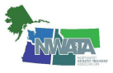
NWATA-District 10
Members Meeting
Saturday, April 2nd, 2022-10:30am to 12:00pm
Portland, Oregon
- Meeting called to order by Director Fitzpatrick at 10:31am, 142 members in attendance
- Welcome and recognition
  - NATA, NWATA and State HOF members
  - Military service
  - Special guests
    - Kathy Dieringer, NATA president
    - Jill Manners, NATA Foundation VP
    - Diane Sartanowicz, D1 Director
    - Katie Walsh Flanagan, D3 Director
    - Rob Marshall, D5 Director
    - Lyn Nakagawa, D8 Director
    - Marisa Brunett, past D9 Director and NATA VP
- Approval of the June 28th, 2021 virtual membership meeting minutes
  - So moved, Kathi Stolts
  - Second, Ciara Ashworth
  - Vote: Ayes -all, Nays-none, abstains-none
- Secretary’s report—Chandra Lovejoy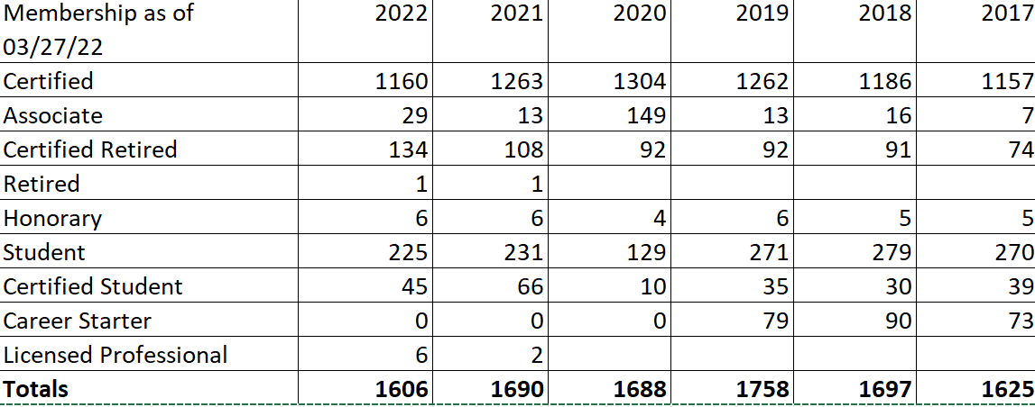
- Treasurer’s report-Garth Babcock

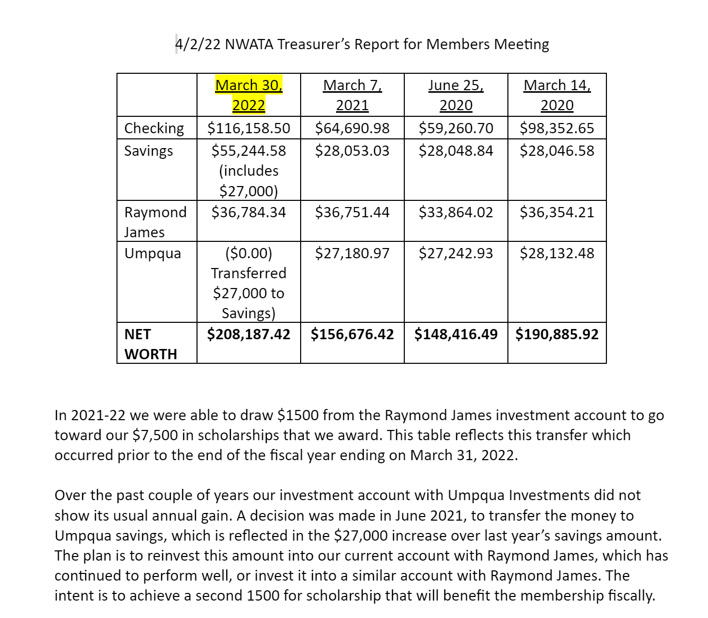
- NWATA Symposium report-Gen Ludwig
  - 412, 149 are students, still getting walk ins; 135 virtual
  - Quiz Bowl-10 teams
  - 15 exhibitors
  - Future meetings:
    - 2023 Spokane
    - 2024-Boise
    - 2025-Bellevue
- Student Update- Dylan Rinaldini, outgoing NWATA Student Senate President
  - Student Symposium went very well, focus was on mentorship and lead off speakers were Ken Kladnik and Paul Capp
  - New students leaders voted in
    - Hannah Boutwell—President
    - Lizzy Godinho-Vice President
    - Chalynne Wisniewski-Secretary
- NATA Foundation
  - Jill Manners/Bill Drake
Growing the future of the AT Profession. The Foundation is a 501c3, the philanthropic arm of the NATA, to advance the profession.
More than scholarships and grants–student writing contest, educational resources, faculty mentor program, position statements, free communications program

- Scholarships: awarded 65 this year
- Grants: in 2021, gave 10 grants for $186,000+ total
- 293 oral presentations at VNATA last year
- 3 different monetary awards for student writing contest
  - NWATA winner: Univ of Montana
- Faculty Mentor Program
  - NWATA Mentor: Cathy Brown Crowell from OSU
- Distinguished Scholar Lecture Exchange Program
  - Research award winners sent to speak at AMSSM, AOSSM, etc in exchange for speaker at NATA
- Implementing the focus on strategic research efforts with an AT agenda
- Position statement collaboration with NATA, 17 statements since 2012. Committee constantly reviews to update as needed
- Educational resources for ATs–infographics such as VOMS, BPPV, etc

- NATAPAC—Tom Bair
  - Apologies for the mix up in glassware for the fundraising, they were not aware it was a mason jar
  - Starting some preliminary conversations to see if NATA would allow GA and NATAPAC co-fundraiser
- NWATA Committee Reports
  - ICSM—Aaron Kilfoyle
  - SSATC-Lynne Young
    - Watch for SSATC sessions at NATA
    - Encouragement to keep pursuing Safe School Awards
    - Reminder about KSI and ATLAS ambassador programs
  - PRAT—Ciara Ashworth on behalf of Midge Peterson
    - NATA Shared Professional Values-PRAT sponsored lecture and research poster at NATA Philadelphia
    - Sports Medicine Legal Digest PRAT sponsored/written article: Standing Orders, What ATs need to know, Winter 2021
    - Continuing to collaborate with the EPC on upcoming projects
- State Reports
  - Alaska–Lynne Young, President
    - Alaska will not be having a CEU meeting this summer, just a members meeting TBD
  - Idaho-Jess Kerns, President
    - Summer Symposium July 22-23
      - Meridian ID at the ISU Meridian Campus
      - HOF Social on Friday night the 22nd
    - 3 BOD positions open
      - Secretary/Treasurer
      - District 1
      - District 3
    - Governmental Affairs
      - Chiropractors amendment bill SB1306-Idaho Concussion bill, heard in Senate but not heard again due to end of session; GA chairs and BOD being proactive to address next year
  - Montana—J. Paul Capp, President
    - Summer Symposium will be held June 10-11 in Helena
    - New President and VP will be voted in this summer
  - Oregon-Heather Halseth, President
    - Summer Symposium TBD as they are looking at 2 separate locations and each location has different dates available, stay tuned for more information
  - Washington---Ciara Ashworth, Interim President
    - Summer Symposium will be July 23rd in Yakima WA
    - New president, VP and secretary was announced at WA state meeting this weekend
- Directors Report
  - A HUGE thank you to ALL our D10 members—Covid was hard and we are slowly getting back to pre-Covid membership numbers because of our amazing District membership
  - DEIA focus from the NATA board of directors on down through the membership
    - BOD worked tirelessly with DEIA task force to make long term sustainable goals for our profession and membership association---we know that BEING SEEN matters
    - Keys areas: Cultivating, Providing, Ensuring, Examining, Increasing and Supporting
  - Strategic Planning
    - Know that the BOD has heard you
      - Membership needs assessment
      - Vision casting meeting
      - Strategic goal planning
      - Know that the BOD knows that decisions are not just for the 12 ATs that sit at the BOD table
      - Committee and task force creations for AT betterment
  - Salary Survey
    - IS OUT TODAY—log into nata.org or look for upcoming NATA news
  - National Dues discussion
    - National dues have not increased since 2011, any recent increases have been a result of your state/district: 2013 was D10 increase from $10 to $25
    - With success comes the cost of doing business FOR our members, and $150 IN 2011 dollars is only about $120 now
    - BOD considering increasing national dues but we SEE the barriers
      - Covid
      - Lost jobs
      - Inflation
    - 2 possible considerations by the NATA Board
      - Raise dues by 1-3% regularly
      - Dues increases as needed due to: inflation, investment outcomes, etc
    - Because of previous financial health of NATA prior to COVID we could handle a lot that came our way, but the loss of 2 national meetings has taken its toll on our financial health and ability to support members as we have wanted and has resulted in the cutting of some things like legislative grants. The 2022 NATA meeting is projected to be a net loss for our association
    - Focus on the positives: federal legislation passing in DC, congressional hearing and meetings have expanded, initiatives funded for states
    - NATA still dedicated to funding efforts for CMS recognition—ACO demonstration and 3rd party reimbursement; medical autonomy
    - Advocacy efforts
      - Value models
      - ATs Care
      - TUFFS
      - ATLAS
      - Leadership Academy
      - Professional Development Center
    - Promoting and ElevATing the AT
      - Expanded representation within setting and specialty groups: task forces, workgroups
      - AT liaisons to NATA partners
      - AT Your Own Risk redesigned
      - NATM
      - NATA logos
    - Increasing visibility
      - Elevating our PR efforts
      - NATM—NATA working for us the AT
    - Alternative to dues increase in association programs decrease
      - Progressive reduction in support, resources—which the BOD does not want to have to do
      - The impact is loss of state legislative grants, other committee grants, projects across the settings, international collaboration
  - Upcoming NATA meetings
    - 2022-Philadelphia
    - 2023-Indianapolis
    - 2025-New Orleans
  - Old Business
    - None reported
  - New Business
    - Kasee Hildenbrand has officially been certified as the new NWATA/D10 Director/President and will take the gavel over for Tony in Philadelphia—a HUGE welcome and congratulations to Kasee and we look forward to your leadership this next term.
    - Next district meeting will be in Spokane-Spring 2023
  - Meeting adjourned 11:58am

