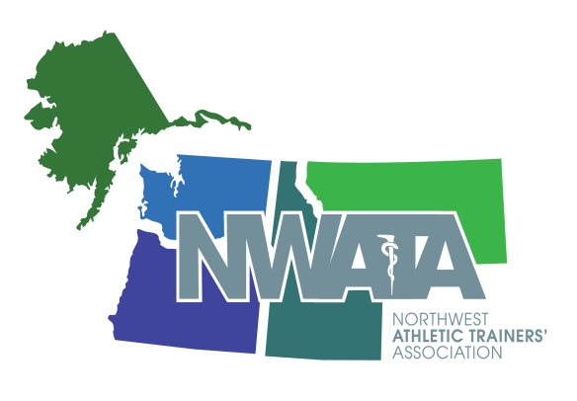

NWATA – Membership Meeting Agenda
Wednesday, June 27th - 5:30 PM
New Orleans, LA - Hilton Grand Ballroom D

- Meeting Called to Order at 5:34pm Tony
108 in attendance

- Introduction of Guests Tony
New members to the district
First time NATA attendees
Special Guests – Lauren and Olivia Matney

- Honors and Awards Tony
  - Membership Longevity Recognition
  - Safe Sports Schools Awards - 25 High Schools in the NWATA have earned 1st Team Status. Since Houston Last Year:
    - ID - Capital HS – Pam Arriola
    - MT - Charlo HS – Matea Depo
    - MT - Columbia Falls HS – Troy Bowman
    - WA - Monroe HS – Leah Straub
    - WA - Wenatchee HS – Dale Blair
  - District Quiz Bowl – Eastern Washington University
  - Foundation Scholarship Winners
- PFATS Robert H. “Bobby” Gunn Scholarship - Yu-Lun Huang – Oregon State University
- NATA Foundation Scholarship - Sienna Antolin - Oregon State University
- Cramer Cornerstone Scholarship - Kelly McCracken – Washington State University
- NBATA Joe O’Toole Scholarship - Mitchell Willert – University of Montana
- District 10- Mark J Smaha Scholarship - Hailie Cowdell – Idaho State University
  - National Scholarship Recipients
  - NATA PR Competition – University of Montana (Best Student Effort)
  - 2017 National Award Recipients
    - NATA Athletic Training Service Award
      - Jennifer Carrol, PA-C, ATC
      - Chris Dean, LAT, ATC
      - Kasee Hildenbrand, PhD, LAT, ATC
    - Most Distinguished Athletic Trainer
      - Dani Moffit, PhD, LAT, ATC
      - Forrest Pecha, MS, LAT, ATC
    - NATA Fellow - Cathleen Brown Crowell, PhD, ATC
    - NATA Hall of Fame – Marty Matney, MBA, LAT, ATC
    - SSATC Servant's Heart award - Dale Blair
    - Gatorade SSATC award: Amy West

- Secretary Report Ben
  - Membership Update
  - GATHER – Online home for Athletic Trainers
  - Decrease in students with transition to Master’s Degree – NATA is helping us investigate to predict budgets, membership changes.
  - Member benefits information – Working on from NATA level as well as NWATA.

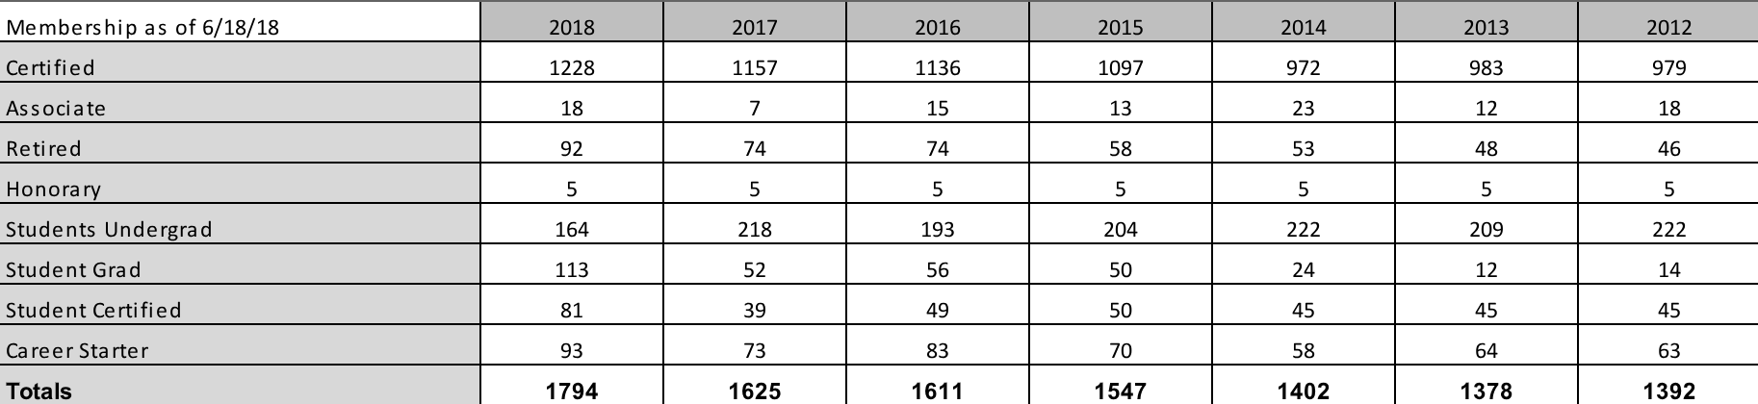
- Treasurer Report Craig
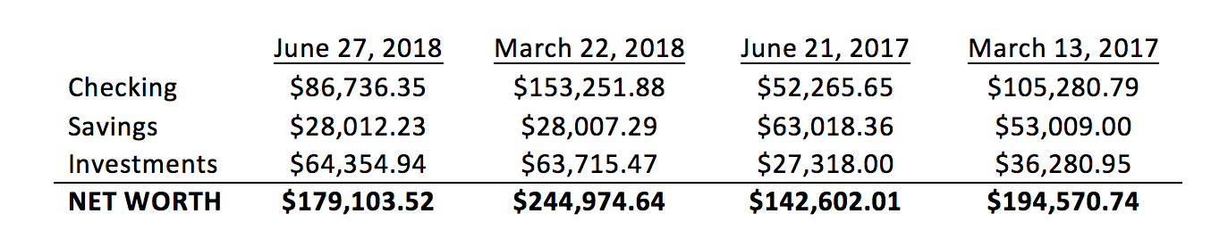

- Director’s Report Tony
- Funding for Spine Injury in Sport Group
  - Initial Research for Best Practices
  - Overseen by University of Washington Harborview
- NATA Sexual Abuse Education Document is now available
  - “What the AT should know about sexual abuse/assault signs, symptoms and duty to report
- ICSM Transition to Practice Document for new collegiate setting hires
- ILead will now move to a yearly event instead of biennially
- Knowledge Initiatives are working with the ECE on educational programs on addressing the new 2020 CAATE Standards and how best to deliver the content
- NATA Foundation has a new research agenda that will focus on 5 Areas
  - Effectiveness & cost-effectiveness of care provided by Athletic Trainers.
  - Studies documenting the outcomes of techniques used by ATs focusing on patient-oriented & quality-of-life outcomes measures.
  - Prospective, longitudinal studies of the epidemiology of conditions typically managed by ATs which will help establish a firm scientific foundation for care provided by ATs.
  - Examining outcomes of various procedures & approaches used in AT education
  - Studies that elucidate mechanisms that have applicability to Athletic Training that could serve as a foundation for clinical practice.
- Approved a New ILead Grant for the LGBTQ+ for a student to attend JCM and become a non-voting member of LGBTQ
- Approved COPA Restructure and Name Change
- Approved funding for ATEC Conference Preceptor Forum
- Address education of AT Educators and Preceptors in regards to the new 2020 CAATE Standards
- Best Teaching Practices / Methodology
- Approved Position Statement on Work-Life Balance
- Liability Tool Kit presentations to Risk Management associations and Insurance companies
  - Create State Specific Liability Tool Kits based on state laws, concussion laws, sovereign immunity, practice acts, good samaritan law, Mandatory Reporting, Pharmacing state laws, other HCP Practice laws
  - Will appear on the NATA website Liability Tool Kit drop down
- Funded a face to face meeting of the Spine Injury Sports Group
  - Follow up from May Board Approval where the SISG researched evidence-based guidelines regarding stabilization and transports of the spine-injured athlete
  - The results of the meeting is to produce a consensus document
  - Will Meet Jan/Feb 2019
- Funded a Sponsorship / FNATA Speaker for the International Sports Science Medical Conference: Diagnosis, Management & Rehabilitation of injuries in Elite Upper Extremity Athletes - London, England - January 2019
- Updated on the NATA TPRI Project in IN, OH, & WI
  - Highlights
    - 1657 More ATs have their NPI Number
    - The number of ATs billing rose from 49 to 118
    - The number of employers billing for ATs increased from 19 to 41
    - The number of payors recognizing for AT PM&R delivered services increased from 37 to 180
  - Produced a document on “Guidance on Billing and Reimbursement for ATs
- 3rd Party Reimbursement Initiative (TPRI)
- Looking for State Reps to work with each Regional Coordinator
- Our Regional Coordinator is Chris Potvin
- Each state will determine who the state rep will be
- Assist States in Establishing a structure that effectively supports the TPRI
- Washington and Montana have Reps
- Sports Medicine Licensure Clarity Act passed through committee hearings and will proceed to the Senate floor for a vote. This is unheard of from an association to promote a bill and be at this stage in just about 5 years when the average bill takes 9-12 years to become law. This will be a historical law for the AT profession as well as other sports medicine professionals! Please keep an eye out for any call to action that may require us to contact our senators for support!

- NWATA News Tony
  - Committee Opening
- Young Professionals Chair
- Specialty Awards D10 Rep
- Athletic Training Service Award D10 Rep
  - Welcome Aboard
- Bill Drake – NATA Foundation District 10 Chair
- Grant Wilson – NATA EDAC District 10 Chair

- District Meeting Update Aaron
  - 2019 Spokane
  - March 28 - 31 Red Lion on the River
  - Local Coordinator: Stacey Nauman
  - Hotel will open up early, before meeting registration. Please register EARLY!

- Committee Announcements
  - Public Relations - Kaleb Birney
    - PR contest will be an all-year contest , not just in March
    - New PR grant – $10,000 total, will award up to $4,000.
  - Secondary Schools – Shelly Jones – ATLAS needs to be completed, updated every year.
  - Governmental Affairs – Lynne Young – Contact Lynne to get involved. Discretionary grants open on July 31st, Aug for matching grant. Investigating opening practices acts to parallel changes in reimbursement.
  - NATAPAC - Dana Gunter – Thank you for donating to NATAPAC. Come visit the NATAPAC booth.
  - NATA Foundation - Bill Drake – Thank you to Scott Richter. NATA 2018 Speakeasy event, Fueled by Gatorade 5K.
  - International Committee - Cynthia Wright – International speaker grant program to raise recognition to international Athletic Trainers. Look out for a survey on international experiences. China job posting for over 100 Athletic Trainers.

- Student report Makenna
  - Madelyne Barton will serve as NATA Chair

- State Presidents Reports
  - Alaska - Lynne Young
    - New executive committee.
    - Safety in Hockey Campaign, carried over to football this year. New Website with sponsors.
    - Created a Secondary Schools Committee, had their first meeting.
    - Quarterly newsletter targeted on their membership
    - Considering opening practice act – investigating definition of word “athlete”.
  - Idaho - Nikki Clark-Vega
    - Joanna Schisel is taking over as President.
    - Capitol Hill Day Scheduled – speaking with other associations about how to converse with legislators.
    - Outstanding Athletic Trainer award is going to be given at their state meeting.
    - Giving away a scholarship this year- multiple applicants.
  - Montana - Valerie Moody
    - State meeting – 55 attendees, 14 students attend.
    - Voted to approve mission and vision statement for association.
    - Working towards creating a Capitol Hill Day in January.
    - Gave out several awards at their state meeting.
    - Elections coming up – call for nominations soon.
  - Oregon - Sam Johnson
    - Summer symposium was on June 1st. Tony attended.
    - Strategic planning session prior to summer symposium
    - Expanding Awareness week, focused on legislatures participation in the first week in September
    - Elections coming up – call for nominations soon.
  - Washington - Jen Carrol
    - State meeting is July 21st at University of Washington. Board of directors and committee chairs positions are full and will be meeting on the Friday before the state meeting.
    - Safety in football campaign for this next season
    - Exploring opening practice act to make some corrections and updates.
    - Hydroflasks are for sale.

- Old Business - None

- New Business - None

- Other

- Adjourn – 6:39pm

Please join us for drinks and hors d'oeuvres immediately following the NWATA-D10 Membership Meeting to celebrate with Marty Matney; our newest NATA Hall of Fame inductee from District 10!

See you in Spokane!

