NWATA - District 10
NWATA Business Meeting - Agenda 2018
Saturday March 24nd 11:45 am – 1:00 pm
In attendance: 223

- Moment of Silence for those NWATA Members we’ve lost since we last met; Clint Thompson and Barney Graff

- Introduction of Guests
  - Strategic Partners
    - NATA – Tory Lindley, Scott Sailor, Dave Saddler, Amy Callendar
    - Foundation - Skylar Gorman
    - CAATE – LesLee Taylor
  - HOF Members & Retired Members

- Approval of June Meeting Minutes – Motion: Russ Richardson, 2nd: Ciara Ashworth, All approved

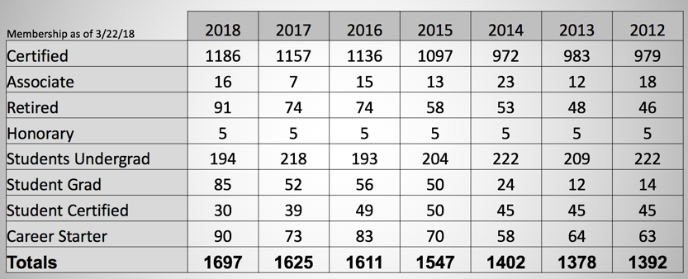
- Secretary Report - Ben Henry – 309 students in NWATA and 200 attended the student session, Gather, PR Video, Liability Toolkit.

- Treasurer Report - Craig Bennett - As of September we have retained the accounting services of Blake Rochette, CPA of Litka, Rochette & Co. who are also the accountants for NATA District 8 (FWATA) and the California Athletic Trainers’ Association.

NWATA invested $35,000 in a Freedom Investment Account with Raymond James with the goal to obtain a dividend of $1500 for one of the NWATA annual scholarships. Over the past seven months the earning has caused the account to fluctuate each month with the current balance of $35,784. We will work with our investment representative to draw from the account as the account matures with the expectation to maintain the principal of $35,000 in the account.

- NWATA2018 Symposium Report - Suzette Nynas – Meeting Recap: 704 registered attendees (120 more than last Portland meeting). Dani Moffit taking over educational programming. Aaron Kilfoyle will be meetings coordinator.

- NWATA-District 10 News
  - NWATA Hall of Fame Inductee, Cari Wood, and District Director award winner, Jim Whitesel were honored last night at awards ceremony.
  - NWATA Students - Erin Boggs, Katy Pietz – Over 200 students attend the student symposium at Clark College. Russ Richardson was keynote speaker. Elections:
    - President: Makenna Turk (University of Montana)
    - Vice President: Sierra Hakanson (Oregon State)
    - Secretary: Erin Guidarelli (Pacific University)
  - NWATA Committees - NWATA Committee Chairs:
    - LGBTQ+ - Dani Moffit – “Committee is for the patients we treat”.
    - EDAC – Dani Moffit – Be the Match program, cards/donations for service members and USO Wishbook.
    - Research – Cynthia Wright – Call for applications for research grants
    - ATs Care – Lisa Kenney – 10 reported incidents in NWATA since August 1st.
    - PR – Kaleb Birney – NATM information, Style books, communication guidelines all on the website. GNAC basketball tournament was a PR highlight. Reminder to send information into Kaleb to post and publish.
    - ICSM – Brian Norton & Anna Taylor – 10 for 10 to educate coaches and administrators.
    - Student Leadership Committee – Mackenzie Holman
    - PRAT – Ciara Ashworth – Duty to our profession to report incidents, goal is to protect the health and safety of our athletes. Check out the code of ethics.
  - State Reports
    - Alaska - Lynne Young: not present, no report
    - Idaho - Nikki Clark-Vega: State meeting in Boise July 20-21st. Joanna taking over as state president in July.
    - Montana - Valerie Moody: Approved a due increase, working on getting a new lobbyist. Working on a Capitol Hill day in Helena. State meeting June 9th.
    - Oregon - Sam Johnson: Concussion HB removed Athletic Trainers from list of “return to play” providers. September/October awareness week for legislators. State meeting on June 2nd in Eugene, OR.
    - Washington - Jennifer Carrol: Recent legislative efforts helped build bridges with PTWA. After last year’s success, AT Campaign this in 2018. State meeting is July 21st at UW.

- NATA Foundation - Scott Richter: Washington led the donation competition, $7600 Ben Henry and Craig Bennett were corn hole competition winners.

- NATAPAC - Dana Gunter (not present, Tony gave report) Thank you for financial support during dues renewal time.

- District Director Report
  - NATM – Shout it from the rooftops #ATshoutout
  - AT Manifesto
  - NATA has hired on a new PR Firm- the YGS group- will support MARCOM with print, digital & media sales. Third Party Reimbursement Project has successfully completed
  - Member Benefit-Go4Ellis the per diem work for ATs is going well and the lowest rate they paid and AT in the first year working with NATA was $32.23/hour
  - A incredible new member benefit that will be rolling out with everyone in the platform very soon called GATHER –The online home for ATs
  - Legislative Action Center available for all States
  - BATS is working hard with the Strategic Alliance on the first specialty certification in Orthopaedics

From the NATA Board of Directors
  - The NATABOD commissioned COPE & PRAT to develop a sexual abuse education program and related resources.
  - The NATABOD approved the PPVM in December from the COPA Physician Practice workgroup. Available on the NATA website.
  - NATABOD approved establishing a TPRI Matching Grant Program, Regional Coordinators and moving forward with a peer reviewed outcomes manuscript.
  - ACO workgroup met in Dallas in December to finalize RFP that will place 1 AT in an ACO/MSO working and billing for rehab services independently. Goal is to gather data that we can go to insurance companies with.
  - NATABOD approved the formation of a new committee the LGBTQ+ Advisory Committee
  - NATABOD approved a networking reception in NOLA for Iota Tau Alpha Professional Honor Society.
  - AT’s care, Lisa Kenney’s efforts with local response
  - NPI Number

NATA National Award Winners
  - Athletic Training Service - Jennifer Carrol, Chris Dean, Kasee Hildenbrand
  - Most Distinguished Athletic Trainer - Dani Moffitt, Forrest Pecha
  - NATA Fellow - Cathleen Brown Crowell
  - NATA Hall of Fame - Marty Matney

- Old Business
  - Secretary Election Results
  - Treasurer Election in the Fall
  - Tabled Motion from March 18, 2018
    - Bylaws Change 4.6.1
    - 4.6.1 Nomination and Election of Officers:
(1) The officers of the Corporation shall constitute the Nominating Committee. The Board of Directors of the NWATA, as established in Articles 3.3.1 and 3.3.2, shall constitute the Nominating Committee. The Nominating Committee shall be chaired by the Past President of the Corporation. If a currently seated officer director is an eligible candidate, they shall choose a proxy to replace them on the Nominating Committee. The proxy should be certified member in good standing with the National Athletic Trainers’ Association. in good standing with the Board of Certification (BOC); members of and in good standing with both the National Athletic Trainers’ Association and Northwest Athletic Trainers’ Association; have a National Provider Identification (NPI) Number.

Motion to approve: Cynthia Wright, 2nd Ciara Ashworth, All approved, motion passed.

- New Business
  - Bylaws Change 4.6.2
  - NWATA Nominating Committee - 4.6 Nomination and Election of Officers.
(2) The Nominating Committee shall present to the Membership, a minimum maximum of three (3) names for each office (if possible). These nominees will be from the membership of the Northwest Athletic Trainers’ Association. All nominees must be Certified members of and in good standing with the National Athletic Trainers’ Association. All nominees must maintain certification with and be in good standing with the Board of Certification (BOC); members of and in good standing with both the National Athletic Trainers’ Association and Northwest Athletic Trainers’ Association; have a National Provider Identification (NPI) Number. Additionally, nominees must have demonstrated prior leadership experience at the local, state, district, or national athletic trainers associations.

  - Motion to approve : Cynthia Wright, 2nd Ciara Ashworth, All approved, motion passed.

- NWATA Recognition
  - Scholarship Winners
    - NWATA Professional Scholarship - Abigail Watkins, University of Idaho
    - Richard Irvin Professional Scholarship - Harli Spurgeon, Eastern Washington University
    - Naseby Rhinehart Professional - Hailie Cowdell, Idaho State University
    - Bill Robertson Professional Scholarship - Olivia Feller, University of Montana
    - Bob Peterson Post-Professional - Yu-Lun Huang, Oregon State University
    - St. Luke’s Emerging Practice - Isabella Callis, University of Montana
    - NWATA Family - Cade Bennett, Emerald Ridge High School
- NWATA Award Winners
  - NWATA Research Grant
    - Nickolai Martonik - University of Idaho
      - “Effect of spiral RockTape application on active females exhibiting dynamic knee valgus”
  - New Horizon
    - Luke Bahnmaier
    - Lisa Kenney
  - Outstanding Service
    - Jennifer Stueckle
    - Cynthia Wright
- Outgoing NWATA Committee Chairs
  - NWATA PR - Josh Holliday
  - NWATA EDAC - Dani Moffitt
  - NWATA Meetings Coordinator - Suzette Nynas
  - Student Leadership – Erin Boggs
  - NATA Foundation – Scott Richter

- Adjournment – 1:05pm

