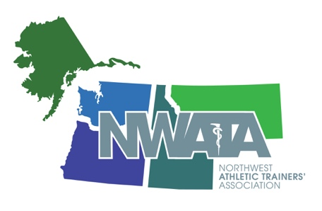
District 10 Service Award
Purpose:

The NWATA District Service Award is given in recognition of those members who have furthered the advancement of the NWATA within District 10 through their contributions and dedicated service to the athletic training profession. The award is to recognize work within the profession at all levels (community, state, district, national). However, this is a district award and implies volunteerism and service within the NWATA by the nominee to assist in the accomplishment of the ongoing work for its members and the betterment of the profession.

Criteria:
- Nominees must be members for a minimum of 10 years in and in good standing of the National Athletic Trainers’ Association (NATA) and the Northwest Athletic Trainers’ Association (NWATA) or have retired in good standing.
- Nominees MUST have made a contribution to the profession of athletic training within District 10 (NWATA).
  - These contributions to the district can be by appointment, volunteerism, committee work, student forums, etc.
  - Contributions to the profession of athletic training at the community, state and national levels are also important and are taken into consideration for this award.

Application Deadline: December 1st

Application Guidelines:
- Any certified athletic trainer, administrator or workplace faculty member may nominate individuals for the Outstanding Athletic Trainer Service Award.
- Nominations can be found and completed online at www.NWATA.org
- Nominees will be notified of their nomination and asked for further information relating to the award.
- Nominations for this award will be reviewed by the Honors and Awards Committee and recommendations made to the NWATA Executive Council for approval.

Presentation:
The award will be presented each year during the NWATA Annual Meeting.

Examples of District 10 (NWATA) Service may include but are NOT limited to:
NWATA Committee work
- Chair or member
NWATA Annual Meeting work
- Volunteer position
- Speaker Moderator
- Session Help
- Quiz Bowl
- Speaker
- Poster Presentation
- Round Table Member
- Registration
Elected NWATA Position
- Director, Secretary, Treasurer, Board of Directors
NWATA Appointed Position

